Table of Contents

1 Chapter 1 – Introduction and Overview of X-ray Spectroscopy 0

1.1 X-ray absorption spectroscopy 0

1.1.1 Experimental modes 1

1.1.2 M- K- and L- Edges 3

1.1.3 Regions of XAS spectra: XANES 4

1.1.3.1 XANES processing 5

1.1.4 Regions of XAS spectra: EXAFS 7

1.1.4.1 EXAFS processing 7

1.1.5 Wavelets 10

1.2 X-ray emission spectroscopy – 3d transition metals 13

1.3 X-ray emission spectroscopy – phosphorus and sulfur 16

1.4 Are XANES and VtC-XES complimentary? 16

1.5 References 17

2 Chapter 2 – Survey of theoretical methods 0

2.1 Density Functional Theory (DFT) (3-4 pgs) 0

2.1.1 Time-dependent density functional theory (TD-DFT) 0

2.2 Theoretical method for VtC-XES and XANES calculations (3 pgs) 0

2.3 NWChem: A closer look (3 pgs) 2

2.4 NWChem: The reliability of the results (3-5 pgs) 2

2.5 NWChem: Implementation (maybe) 2

2.6 References 2

# Chapter 1 – Introduction and Overview of X-ray Spectroscopy

The following chapter gives a brief overview of X-ray absorption and emission spectroscopies, including nomenclature and typical uses. For a more detailed discussion, see the many excellent review articles and key papers on XAFS, including but not limited to Rehr and Albers [Rehr, 2000 #95], Sayers, Stern, and Lytle [Sayers, 1971 #241], Bunker [Bunker, #92], Ashley and Doniach [Ashley, 1975 #242], Newville, [Newville, 2014 #246], and Glatzel and Bergmann [Glatzel, #58].

Specifically, I will focus on the uses and chemical and electrical sensitivities of absorption versus emission spectroscopies, namely X-ray absorption near edge fine structure (XANES) and Valence-to-Core X-ray Emission Spectroscopy (VtC-XES). I will compare their uses in the context of the strength of the information they encode in their respective spectra, framing the question of whether their information is complementary – a major contribution of this dissertation.

## X-ray absorption spectroscopy

X-ray absorption spectroscopy (XAS) has been used as an important tool in many fields of science, such as materials science, physics, biology, chemistry, geosciences, and electronics. XAS, which produces spectra known as X-ray absorption fine structure (XAFS), is a bulk probe of both electronic and geometric structure around a chosen atomic species and is sensitive to properties such as oxidation state, valency, coordination, and bond length. When X-rays are shone onto a sample, they can either kick the electron out of the system (for X-ray Photoelectron Spectroscopy, or XPS) or push the system into an excited stated by kicking the electron to an unoccupied energy level (for XAS). There is an intrinsic lifetime of this excited state unique to the atomic species and hole. Finally, an electron from an occupied state will fall back down to fill the hole (creating X-ray Emission Spectroscopy, or XES) or radiate via two-electron processes, such as through the Auger−Meitner effect, as demonstrated in Fig. 1.

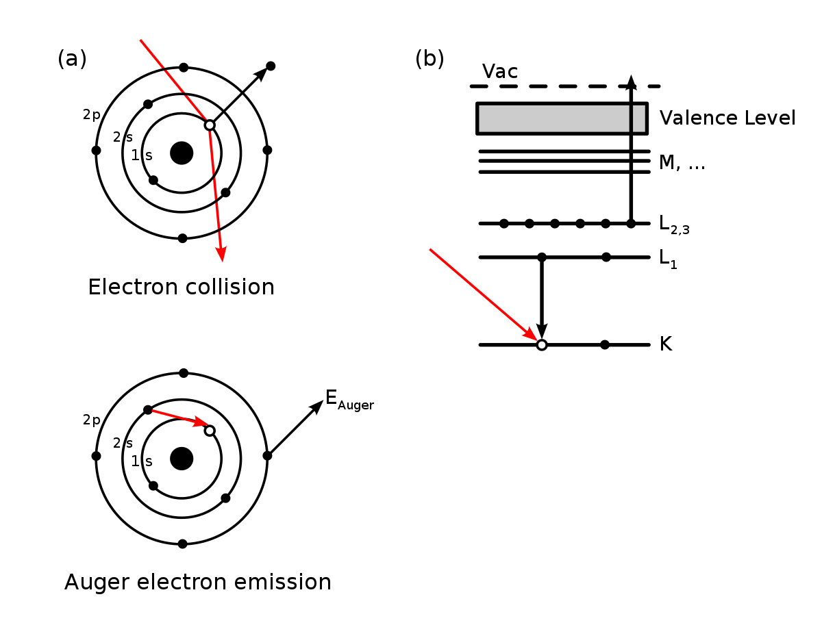

Fig. 1 The Auger-Meitner [Matsakis, 2019 #255;Meitner, 1922 #256] effect is a two-electron process, where an inner-shell electron falls to fill the core hole, thus emitting a photon, but the rest of the extra energy is dissipated by emitting a valence electron.

### Experimental modes

Experimentally, XAS can be performed either in transmission or florescence mode. Transmission mode is when the monochromatized X-rays must pass through the sample before entering the detector. Florescence mode occurs when the monochromatized X-rays hit the sample and the fluorescence off the sample enters the detector. In florescence mode, there is no background shape (besides stray scatter, if there is any). In this case, the absorption coefficient µ(E) can be solved for as If(E)/ I0(E).

Fluorescence mode, or X-ray Fluorescence (XRF), is different from X-ray emission spectroscopy (XES) due to the difference in resolution and thus their uses; in XES, the high resolution allows for distinct differentiation between the emission lines, whereas XRF is low-resolution over a much larger energy range and is thus used for qualitative identification of elemental composition.

When in transmission mode, the shape of the background is important to identify the XAS spectra, given by the absorption coefficient µ(E). Transmission-mode XAS is governed by Beer’s law

I(E) = I0(E)e-µ(E)x (1)

where x is the sample thickness, I(E) is the loss spectra (i.e., the photon counts after passing through the sample) and I0(E) is the X-ray spectrum without sample. A cross-section is shown in Fig. 2. [Rehr, 2000 #95] We could solve for x*µ(E) as – ln (I(E) / I0(E)). We will normalize out the sample thickness (x) later.

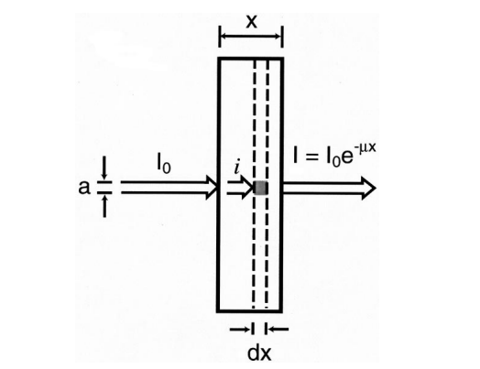

Fig. 2 Absorption coefficient for XAS. Taken from Rehr and Albers. [Rehr, 2000 #95]

### M- K- and L- Edges

µ(E) looks like a set of stairs, where each step, or edge, corresponds to an excitation energy of different inner-shell electrons. Each edge has a name and are commonly referred to using the IUPAC notation, as shown in Fig. 3. Exciting electrons from the 1s (n = 1) shell is called K-edge spectroscopy, while exciting electrons from the n = 2 shell are the L edges and the n = 3 the M edges. Each edge is then broken down further based the orbital angular momentum quantum number (l) and the magnetic quantum number (j). For example, exciting the 2s shell is the L1 edge, exciting from the 2p1/2 shell is the L2 edge, and from the 2p3/2 shell is the L3 edge. The same pattern continues for the M edges.

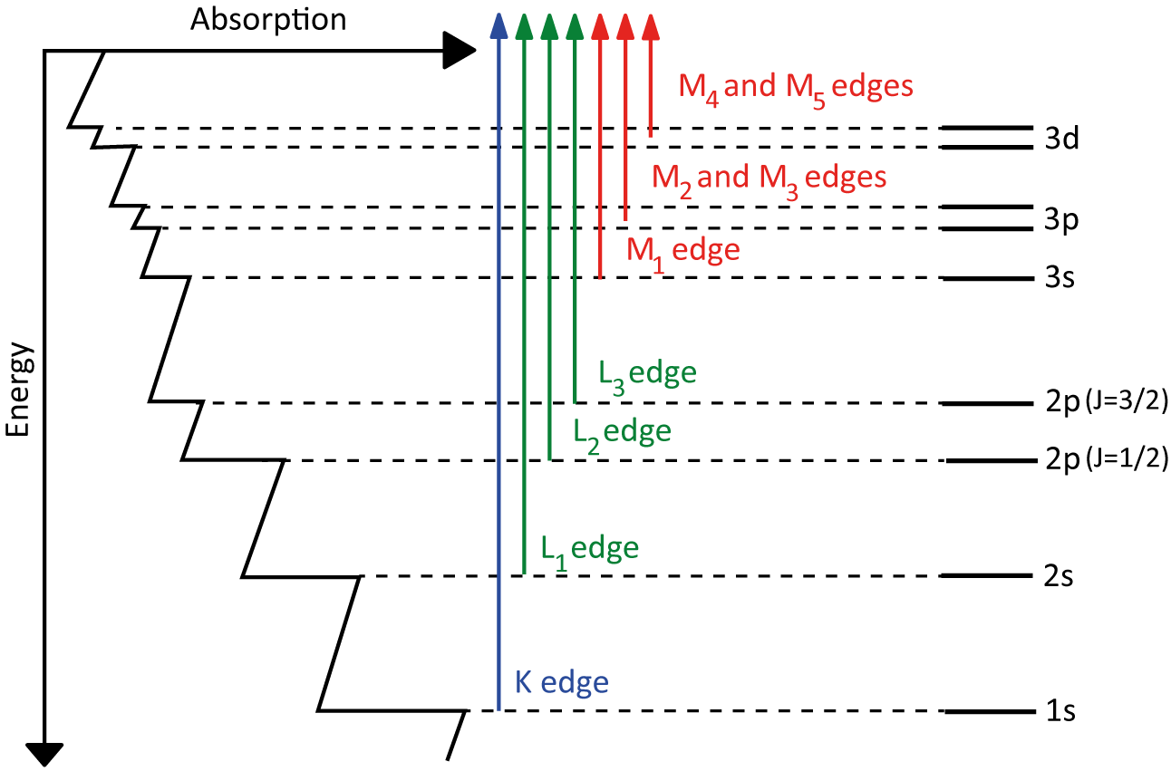

Fig. 3 Absorption edge of an element can be broken down into K, L, and M edges.

### Regions of XAS spectra: XANES

Zooming in onto these edges, you will see characteristic oscillations, as shown in Fig. 4. The XAS spectrum can be broken into two different regions – X-ray absorption near edge fine structure (XANES) and Extended X-ray Absorption Fine Structure (EXAFS). [Rehr, 2000 #95] XANES includes any pre-edge features, shoulders, and the region around the edge step, while the EXAFS includes the oscillations at higher energy.

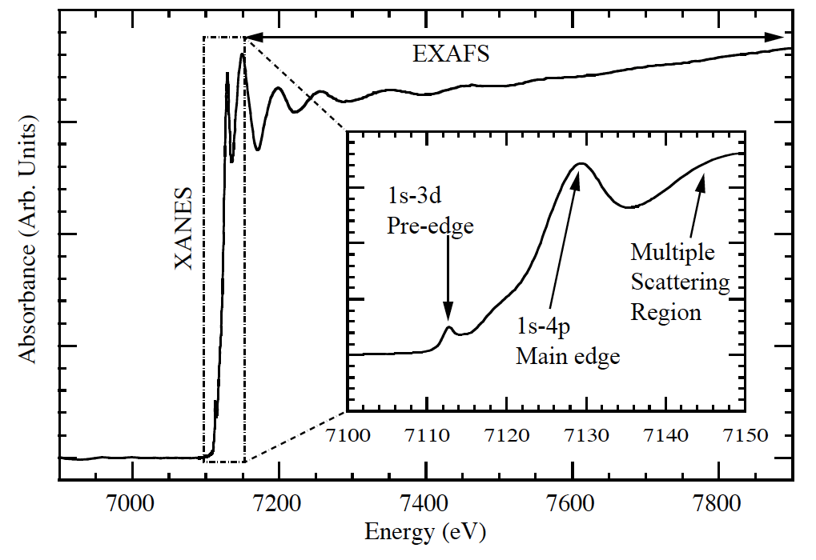

Fig. 4 The XANES and EXAFS regions of XAS spectra.

X-ray absorption near edge fine structure (XANES) is the region of XAS around the absorption edge, from any pre-edge features to about 50 eV past the edge, depending on the system. Because XANES probes electronic states near the Fermi level, it is sensitive to local electronic structure around the chosen atomic species, such as oxidation, spin, and valency. Calculating XANES spectra requires full multiple scattering theory and has broadening to transitions due to the lifetime of the core hole.

#### XANES processing

Because spectral features in the XANES spectra are often correlated, meaning two chemical properties can cause the same spectral trends, the most common analysis for XANES spectra is linear combination fitting onto reference spectra. Selecting reference spectra can be tricky because they must encapsulate the experimental domain, so their choice relies on prior knowledge of the scientific system. Moreover, differences in the second and third coordination shells between the reference structures and experimental sample can have negative influences on the reliability of these fits. [Jahrman, 2022 #206]

Furthermore, proper fitting requires proper “normalization,” as defined by the standard processing tools in Athena [Ravel, 2005 #97] and Larch [Newville, 2013 #193]. Normalizing XANES spectra is defined as fitting a pre-edge line and a post-edge polynomial function (either constant, linear, or quadratic), where the edge is determined as the maximum of the derivative. The pre-edge fit is then subtracted from the entire XANES spectrum, and the post-edge is rescaled such that the fitted polynomial curve falls along the line y = 1 after the edge. This process not only removes global scaling due to differences in sample thickness (i.e., number of atoms), but gives a consistent spectral shape. [Newville, 2014 #246] An example of this process is shown in Fig. 5.

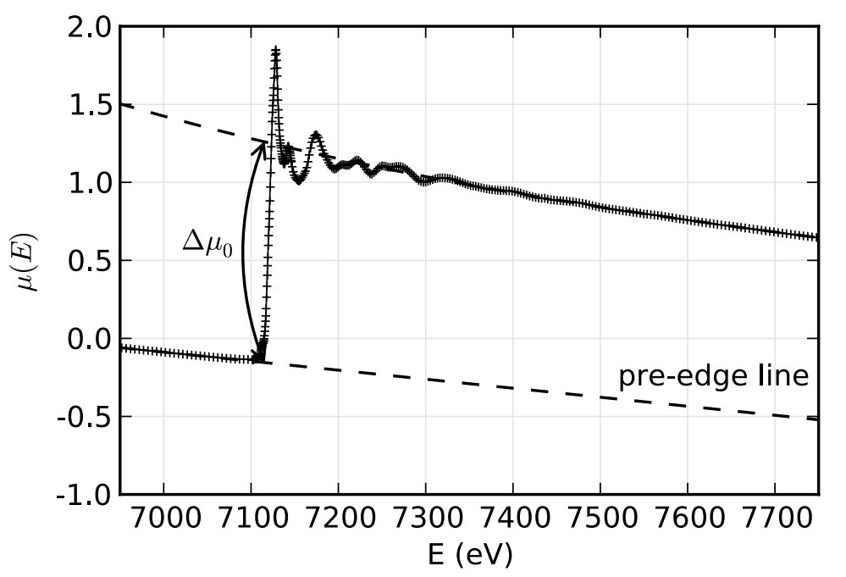

Fig. 5 An example of the normalization process for XAFS, where the pre-edge line is set to be along the y = 0 line, and the post edge line is set to be along the y = 1 line such that the edge step Δµ is one. Taken from Newville. [Newville, 2014 #246]

### Regions of XAS spectra: EXAFS

Extended X-ray Absorption Fine Structure (EXAFS) is weak multiple scattering and the higher energy oscillations past the absorption edge. EXAFS is sensitive to local geometric structure, such as coordination and bond length. Calculating EXAFS involves multiple scattering and the assumption of a muffin-tin potential, and much work has been done to utilize real-space Green’s functions to quickly calculate EXFAS via the FEFF program. [Rehr, 2010 #26]

#### EXAFS processing

An important aspect of EXAFS analysis derives from the parameters in the EXAFS equation. The EXAFS equation [Sayers, 1971 #241] is given as

(2)

where k = 2π/λ is the photoelectron vector, Nj is the number of equivalent scatterers (or coordination number), f(k) is the scattering factor, σ2j is the Debye-Waller factor, rj is the distance from the absorbing atom to the scatterer, and η(k) is the phase shift. [Sayers, 1971 #241] Because f(k) and η(k) can be calculated for a certain value of k, the only parameters left are Nj, rj, and σ2j. Because the Debye-Waller factor is just a term that represents disorder, it is simply used in fits but not an important scientific parameter. That leaves the two scientific important parameters – Nj and rj – left.

This analysis is done using the community standard tools: Athena [Ravel, 2005 #97] and its newer cousin Larch [Newville, 2013 #193]. Typically, you start with the normalized spectra following the same procedure in the XANES section of setting the edge to go from zero to one. Then, by removing the smooth post-edge background function you get the isolated XAFS χ(E), where χ(E) = (µ - µ0) / Δµ. Then, through a Fourier transform, the χ(E) is transformed to χ(k), where k is momentum, or

(3)

From χ(k), different fits and analysis can be performed to achieve the free parameters in the EXAFS equation. Often, because the high k features get washed out compared to the high amplitude but low k features, people will “k-weight” χ(k), i.e., multiplying χ(k) by either k2 or k3 to pronounce the higher k features. You can then Fourier transform the k-weighted χ(k) intro R space to achieve bond lengths. [Newville, 2014 #246]

Seminally, this spectroscopy and analysis technique was shown in Sayers, Stern, and Lytle [Sayers, 1971 #241] on crystalline and amorphous Ge, as shown in Fig. 6. Here, the crystalline Ge (Fig. 6a) clearly has more structure and detail than the amorphous Ge (Fig. 6b).

Fig. 6 Smoothed experimental EXAFS data for (a) crystalline Ge and (b) amorphous Ge. Only the oscillatory part χ of the absorption edge is shown. Figure taken from Sayers, Stern, and Lytle. [Sayers, 1971 #241]

Taking the Fourier Transform of the data using the EXAFS equation is shown in Fig. 7. Note that the absolute value of the amplitudes has no physical significance, but the relative values of the peaks can be interpreted using the equation

(4)

where the amplitude can indicate the relative number of atoms in that coordination shell, or with that bond distance. However, information about both the thermal and disorder in the system is needed to determine the appropriate broadening of the peaks. [Sayers, 1971 #241]

Fig. 7 Fourier transform of the data in Fig. 6. φ(r), a radial structure function, compares amorphous and crystalline Ge. Numbers over the peaks indicate the measured distances inÅ. Figure taken from Sayers, Stern, and Lytle. [Sayers, 1971 #241]

### Wavelets

Another qualitative analysis of EXAFS that has seen recent traction is wavelet analysis. Wavelet transforms have shown to be a qualitative excellent way for filtering EXAFS contributions by Z, or atomic number, of the scattering species. This benefit capitalizes on the fact that larger Z atoms have smaller (spatially) electron orbitals [Muñoz, 2003 #247] and thus have a larger spread in momentum, which allows scattering in a larger k range than lighter Z atoms. A demonstration of the wavelet transform can be seen in Fig. 8, which shows the k-weighted χ(k) data visualized in three-dimensions, where one dimension is “distance” (from a k-weighted transform), the second dimension is momentum k, and the third dimension is the value of the modulus squared of the wavelet transform.

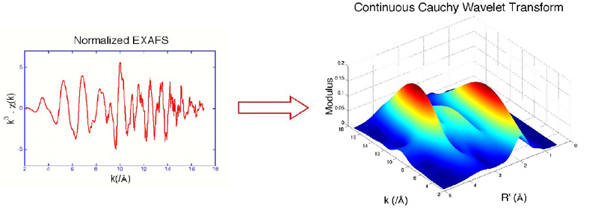

Fig. 8 Wavelet analysis can separate contributions based on the atomic number Z of the scatterer. Taken from Munoz, et al. [Muñoz, 2003 #247]

For a time-series dataset, where sampling occurs using the typical Shannon-Nyquist sampling rate, you can perform a Fourier transform to convert into frequency space. However, this analysis assumes signals are “stationary,” meaning they occur throughout the entire time of the signal, or there are no “events”.

One way to solve this issue is to evenly divide time and frequency resolution. However, this approach can be an issue if, for example, signals very in time duration. Wavelet transforms use the idea that low frequency signals occur over longer periods of time and thus need better frequency resolution. Conversely, higher frequency signals occur over a short time scale and thus need better time resolution. The difference in resolution can be seen in Fig. 9.

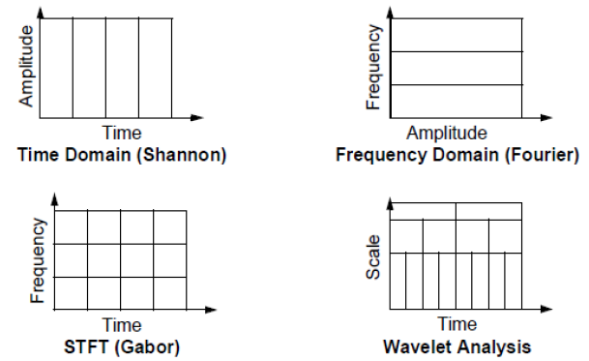

Fig. 9 Wavelet analysis is like Fourier transforming using different frequency (or conversely time) sampling rates to create a “multiresolution” transform.

This change in resolution is generated using a “mother” wavelet and adjusting the scale (and thus resolution). For example, this mother wavelet could look like

where a is the squishiness, or scale, of the wavelet and b is the time interval. Examples of specific wavelets ψ (which must be discrete) include the Haar, Mexican hat, Daubechies, and Coiflet wavelets, depending on the type of data. The final wavelet transform is obtained by taking the inner product of the signal with all the wavelets (which form an orthogonal basis), given as

This inner product gives a complex value, where the modulus squared can then be interpreted, as is the case for XAFS wavelet analysis.

## X-ray emission spectroscopy – 3d transition metals

X-ray emission spectroscopy (XES) occurs when an excited atom emits a photon as an electron falls to fill the vacancy. Emission lines are similarly named as XAS by the hole location, or shell in which the electron was originally excited from. For example, having electrons fall into a 1s core hole is K fluorescence. The initial shell of the falling electron then dictates whether the spectra are Kα (2p to 1s) or Kβ (3p to 1s). A breakdown of the K emission lines and their corresponding names can be seen in Fig. 10.

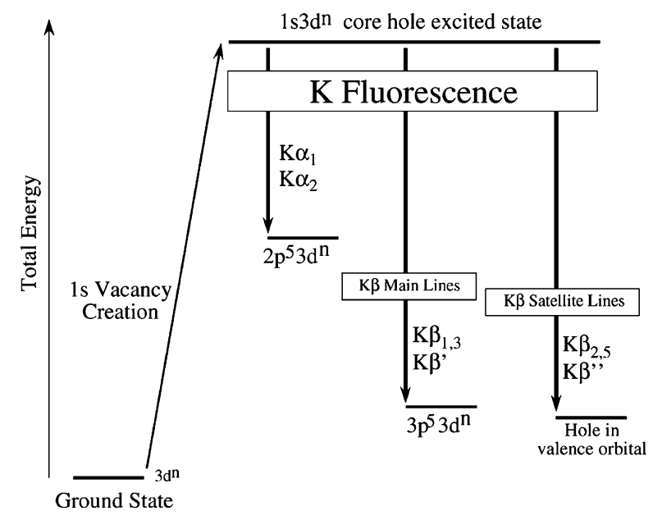

Fig. 10 Conventional naming of florescence lines.

The relative intensity of the different K emission lines is demonstrated in Fig. 11. Here, the Kα lines are much more intense (by a factor of about 3) than the Kβ lines. Furthermore, the Kβ satellite lines (or electrons falling from the valence shell, i.e., the 3d orbital for 3d transition metals) are smaller by a factor of about 500. This difference in photon counts is exactly due to dipole selection rules and is important to consider when deciding on which emission line to probe.

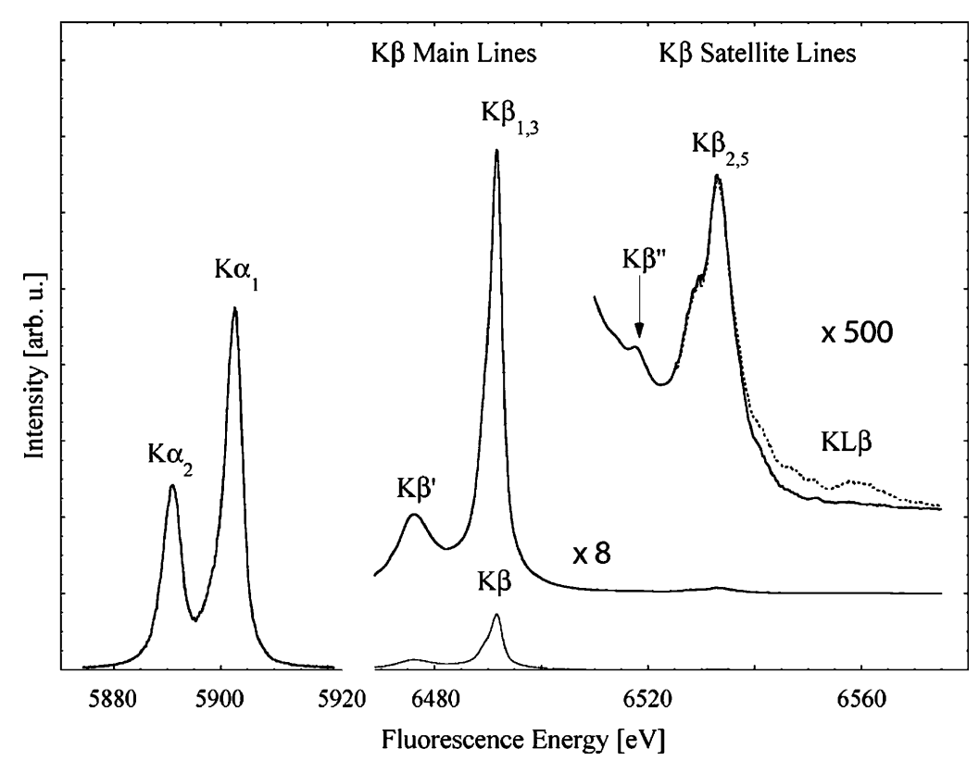

Fig. 11 The Mn K-fluorescence lines for MnO. [Glatzel, #58]

Core-to-core X-ray Emission Spectroscopy (CtC-XES) includes the Kα and Kβ lines (at least for 3d transitions metals). An in-depth discussion of CtC-XES is included in Glatzel and Bergmann. [Glatzel, #58] The utility of XES was notably demonstrated in Bergmann, et al. [Bergmann, 1998 #243], which studied the oxidation state of Mn in Photosystem II via the Kβ emission lines.

One benefit of Kα emission spectra is that it is not sensitive to second order environmental factors as the orbitals are too deep to be drastically hybridized. Thus, it is expected that the total oscillator strength of the Kα lines is proportional to the number of atoms. Thus, the integral of the Kα spectra can be theoretically used as a normalization, or scaling factor, for the other K emission lines.

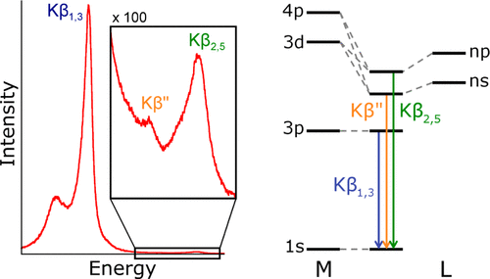

Fig. 12 Molecular orbital perspective of Kβ and its satellite lines.

For 3d transition metals, the Kβ satellite lines are also called Valence-to-Core XES (VtC-XES) andis highly sensitive to ligand identity due to the hybridization of orbitals, as shown in Fig. 12. Study of VtC-XES has been relatively new because only the recent improvements in synchrotron and lab-based spectrometers has made this experiment possible. Notably, Pollock and coworkers have developed a theoretical approach to calculating VtC-XES [Pollock, 2014 #244] and used it to study the iron oxidation in the iron-molybdenum cofactor (FeMoco) in nitrogenase. [Lancaster, 2011 #245] However, although VtC-XES is sensitive to ligand identity and other ligand properties, it is not a good quantitative method (rather, it qualitatively follows trends) to determining those properties. [Pollock, 2015 #68]

## X-ray emission spectroscopy – phosphorus and sulfur

For elements with their valence shells in the 3p orbital, such as phosphorus and sulfur, the Valence-to-Core XES (VtC-XES), which were the Kβ satellite lines for the 3d transition metals, now becomes just the Kβ satellite lines, meaning VtC-XES becomes dipole allowed and thus is way stronger in intensity compared to the non-dipole allowed transitions for the 3d shell. A large section of this dissertation is focused on the VtC-XES of both phosphorus and sulfur. Works have shown that VtC-XES for phosphorus and sulfur can help identify chemical classes. [Holden, 2020 #37;Yasuda, 1979 #35;Yasuda, 1984 #143;Mathe, 2021 #258]

## Are XANES and VtC-XES complimentary?

XANES and VtC-XES are often seen as “complimentary” [Mori, 2010 #73;MacMillan, 2015 #81;Qureshi, 2021 #82] as they are sensitive similar properties even though they probe different states, as demonstrated in Fig. 13. Much of this dissertation focused on analyzing whether VtC-XES and XANES are indeed complementary in terms of the strength of the chemical information they encode, or if this information is just highly coincidental.

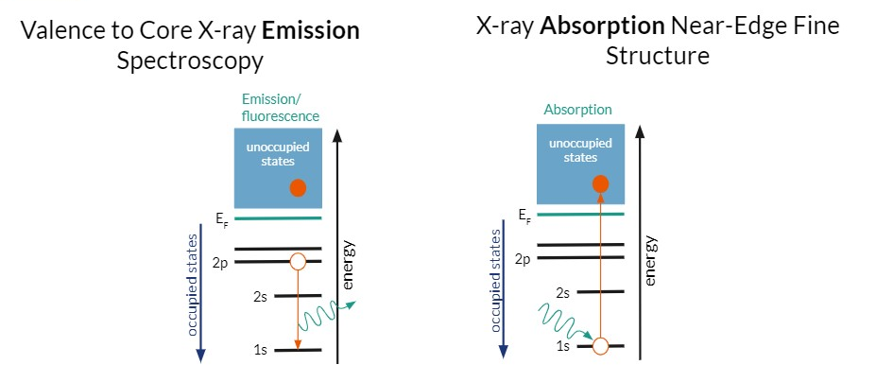

Fig. 13 VtC-XES probes occupied electronic states while XANES probes the unoccupied electronic states.

For example, Jahram et al. [Jahrman, 2020 #116] showed that the VtC-XES of V of various V oxides lacked distinct spectral features because of the high symmetry and simple bonding environment rather than the lack of sensitivity of VtC-XES. Additionally, it is expected that 3d transition metals without any 3d electrons (e.g., Cr6+) or with complete 3d shells (e.g., Zn2+) will have sensitivities in either XANES or VtC-XES, but not both. Or one technique, such as XANES, will be too sensitive and thus encode too much information, creating correlated features and thus muddling experimental conclusions. [Jahrman, 2022 #206] Thus, these examples bring up the questions of the strength of chemically relevant information encoded in each spectroscopy technique.

## References